API Reference

http://www.mujoco.org/book/APIreference.html

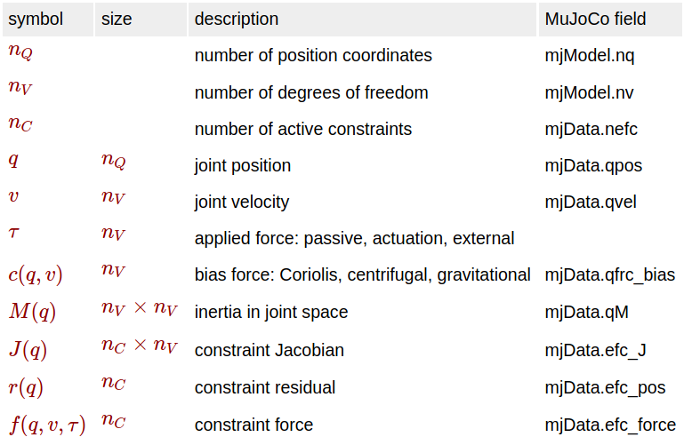
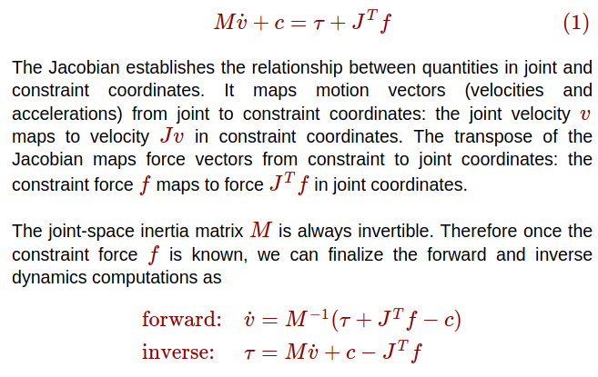

Transmission
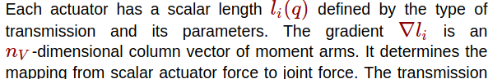

Activation dynamics

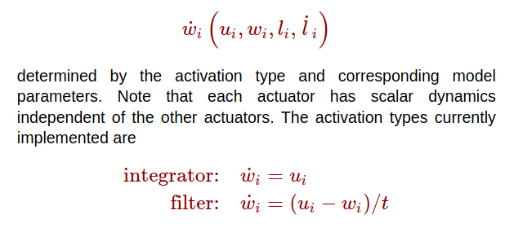
Force generation
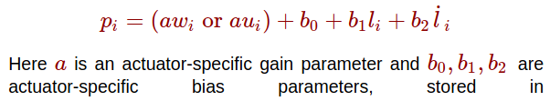
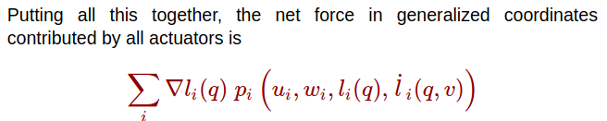

Passive forces

MuJoCo can compute two types of passive forces: spring-dampers in joints and tendons, and fluid dynamics.

Numerical integration
